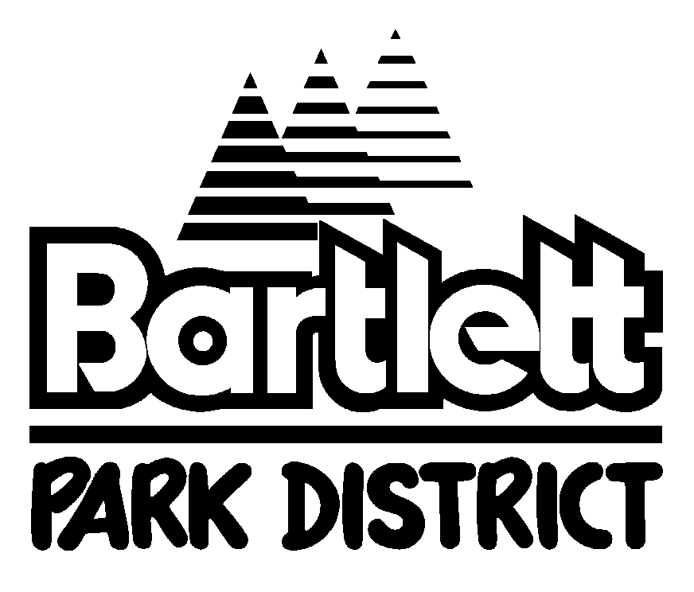
2023 Nutcracker: All Jazzed Up! Audition Form
Please Attach Dancer Photo
Name: Grade Entering in Fall: Age:
Address: City: Zip:
Email Address: Phone:
T-shirt Size: Costume Size:
Please utilize costume sizing information (Reverse side of page) to estimate the size costume your child will wear. We will use this information as a guide when assigning costumes for our performers. We cannot guarantee a specific size, but will use this as a guide to find the best fit for your child. All correspondence will be via email.
Please provide an email address that will be checked regularly.
Performances & Rehearsals:
1st Wknd: Dec. 1: 7pm and Dec. 2: 12pm, 3:30pm & 7pm 2nd Wknd.: Dec. 8: 7pm and Dec. 9: 12pm, 3:30pm, 7pm
We anticipate rehearsals will be held Mondays, Tuesdays, Wednesdays and Thursdays as early as 4pm. The number of rehearsals your child will attend depends upon their role in the show. Dancers are expected to be at all scheduled rehearsals that involve their character/scene. Replacement due to absences is at the discretion of the Director and/or the Bartlett Park District. Significant conflicts with performances may affect casting. Below, please select your availability for performing. List any and all conflicts that may prevent you from being at performances:
I am only available to perform December 1-2.
I am only available to perform December 8-9.
I am available to perform both weekends.
Please list your most significant on-stage performances (If none, please leave blank):
Role | Production/Organization | Year
Please list any other information you feel the director should know about your dance background including training, length of training, other talents (i.e. gymnastics):
As a potential participant, I pledge to support the organization with my abilities and talents. I also understand there is a program fee. The registration form and fee are due prior to the first rehearsal. In addition to the program fees, all families are expected to volunteer to assist with the productions.
Signature (Under 18, parent/guardian signature) Date
We would like to thank you for your interest in the Nutcracker: All Jazzed Up! Unfortunately, we are unable to cast everyone who auditions. There are always opportunities to assist with the production if you are not cast. Please call Lisa 630-372-0160 or Cydnie Babicz at 630-540-4873 to learn how you can be part of the production.

